SIMATS ENGINEERING
(SAVEETHA SCHOOL OF ENGINEERING)
Department of Computer Science and Engineering
CO1 ASSESSMENT TOOL 1 – CASE STUDY ANALYSIS
Course Code: | CSA10 | Course Title: | Software Engineering
CO Assessed: | CO1 | Assessment: | Assessment Tool 1 – Case Study Analysis
Weightage: | 20% | Total Marks: | 25 Marks
CO1 Statement: | Apply advanced methodologies and agile project management techniques to manage software projects effectively
Student Name: | Haashini P | Reg. No.: | 192524047
Date: | 14-10-2026 | Duration: | 60 minutes

Code of Conduct:
I, Haashini P (Reg No: 192524047), certify that this submission is my original work and that I have adhered to the guidelines specified for this assessment. I understand that any violation of academic integrity rules will result in disciplinary action.
Signature of the Student: _________________________________ Date: 14-10-2026

CASE STUDY ANALYSIS REPORT
ASSIGNED PROBLEM STATEMENT #7:
CROP DISEASE DETECTION AND FARM ADVISORY PLATFORM
Industry Sector: Agriculture & Precision Agronomy | Target Platform: CropCare AI

TABLE OF CONTENTS
Section | Title / Assessment Requirement | Page
1.0 | Introduction & Academic Context | 3
2.0 | Question 1: Understanding the Problem Statement | 4
2.1 | Problem Explanation and Socio-Economic Impact | 4
2.2 | Objectives of the Proposed System | 5
2.3 | Scope and Architectural Boundaries of the Problem | 6
3.0 | Question 2: Stakeholder Identification and Challenge Analysis | 7
3.1 | Comprehensive Stakeholder Identification | 7
3.2 | Stakeholder Roles and Responsibilities Matrix | 8
3.3 | Key Domain, Operational, and Technical Challenges | 9
4.0 | Question 3: Analysis of the Current Approach | 11
4.1 | Description of the Existing System and Conventional Process | 11
4.2 | Strengths of the Conventional Agricultural Process | 11
4.3 | Limitations and Bottlenecks of the Current Approach | 12
4.4 | Systematic Gap Analysis Matrix | 13
4.5 | Summary of the Core Problem to be Addressed | 14
5.0 | Question 4: Proposed Software Solution & Software Engineering Principles | 15
5.1 | Proposed System Overview (CropCare AI Architecture) | 15
5.2 | Five-Layer Software Architecture Design | 16
5.3 | Major Functional Modules Specification (Modules 1 to 8) | 17
5.4 | Functional Requirements Specification (FR-01 to FR-12) | 19
5.5 | Non-Functional Requirements Specification (NFR-01 to NFR-10) | 21
5.6 | Application of Core Software Engineering Principles (A to I) | 22
5.7 | Data Management and Relational Schema Design | 24
5.8 | Security, Authorization, and Privacy Architecture | 25
5.9 | End-to-End System Workflow Execution | 26
6.0 | Question 5: Justification of the Chosen Methodology (Agile with Scrum) | 27
6.1 | Rationale for Selecting Agile Scrum for Precision Agronomy | 27
6.2 | Scrum Team Roles and Academic Project Allocation | 28
6.3 | Scrum Ceremonies, Artifacts, and Feedback Governance | 29
6.4 | Four-Sprint Proposed Implementation Plan (Sprint 1 to 4) | 30
6.5 | Agile Support for Maintenance, Audits, and Evolution | 31
7.0 | Question 6: Expected Outcomes, Challenges, and Limitations | 32
7.1 | Expected Socio-Economic and Agronomic Benefits | 32
7.2 | Challenge vs. Proposed Feature vs. Expected Benefit Matrix | 33
7.3 | Technical Risks, Implementation Challenges, and Mitigation | 34
7.4 | Systemic and Operational Limitations of AI Diagnostics | 36
7.5 | Strategic Future Enhancements and Scalability Roadmap | 37
8.0 | Conclusion | 38
9.0 | References | 39

1.0 INTRODUCTION
Agriculture represents the foundational backbone of global sustenance, economic stability, and rural livelihoods, employing over one billion individuals worldwide and serving as the primary source of food security. In developing and agrarian economies, agricultural productivity directly dictates Gross Domestic Product (GDP) growth, foreign exchange reserves, and household prosperity. However, agricultural ecosystems remain exceptionally vulnerable to biological pathogens, environmental stressors, and erratic climatic perturbations. Among these threats, crop diseases caused by pathogenic fungi, bacteria, viruses, phytoplasmas, and pest vectors represent the most catastrophic source of direct yield loss, accounting for an estimated 20% to 40% reduction in global agricultural output annually according to the Food and Agriculture Organization (FAO).
Historically, farmers have relied upon visual inspection, experiential memory, and traditional indigenous agricultural lore to detect abnormalities across their fields. While manual scouting has sustained farming communities for generations, it suffers from acute limitations when applied to commercial or large-scale monoculture and polyculture acreage. Pathogenic infections frequently initiate at microscopic, cellular, or lower-canopy tiers, exhibiting subtle discoloration, chlorosis, or minute necrotic lesions that easily evade the naked human eye during routine inspections. By the time visual symptoms become prominent—such as widespread foliage necrosis, stem rot, or vascular wilting—the pathogen has already achieved systemic propagation within the plant vascular network, rendering remedial chemical interventions ineffective and triggering devastating regional crop collapse.
The consequences of delayed disease detection are multifaceted and severe. For smallholder and marginal farmers, sudden crop failure precipitates severe financial indebtedness, destruction of invested capital, and localized food scarcity. For regional agrarian cooperatives and national supply chains, uncontained disease outbreaks result in astronomical commodity price volatility, market export rejections due to pesticide residue non-compliance, and degradation of soil microbiomes resulting from indiscriminate, unscientific chemical pesticide over-spraying. Farmers frequently react to unidentified foliage damage by blanket-spraying broad-spectrum toxic fungicides or chemical cocktails, which not only fails to neutralize bacterial or viral agents but also accelerates chemical resistance, decimates beneficial pollinator populations, and pollutes local aquifers.
In contemporary software engineering and precision agriculture, advancements in digital technologies—specifically artificial intelligence (AI), computer vision (CV), distributed cloud architectures, and agro-meteorological analytics—offer a revolutionary avenue to overcome these legacy diagnostic bottlenecks. Modern digital smartphones equipped with high-resolution image sensors enable growers to capture clear foliage photography directly in the field. When integrated with deep learning convolutional neural networks (CNNs), automated image segmentation algorithms, and agronomic rule bases, digital software platforms can perform rapid, standardized, and reproducible leaf pathology classifications within seconds.
Nevertheless, isolated image classification tools in the existing literature frequently fail because they treat disease identification as an academic classification problem devoid of field context. An image diagnosis alone does not inform a farmer whether impending monsoonal rains will wash away an applied copper spray, whether soil nitrogen deficiency precipitated the infection, or whether neighboring fields are at immediate risk of airborne fungal spore infestation. Therefore, an integrated, end-to-end software platform—entitled CropCare AI—is urgently required. This platform systematically unifies computer-vision disease diagnosis, multi-plot field monitoring, microclimate weather telemetry, longitudinal historical health dossiers, regional outbreak alert networks, and expert-reviewed agronomic advisory services into a unified, modular, and scalable software engineering system.

2.0 QUESTION 1: UNDERSTANDING THE PROBLEM STATEMENT
2.1 Problem Explanation in Context
Assigned Problem Statement #7 focuses on the design and architectural formulation of a 'Crop Disease Detection and Farm Advisory Platform' operating within the agricultural industry domain. In essence, the problem originates from a severe diagnostic and advisory asymmetry in contemporary farming: while biological pathogens operate on rapid, exponential reproductive cycles governed by temperature and humidity, the human systems available to diagnose and prescribe countermeasures operate with substantial latency, geographical friction, and subjective inconsistency.
To clearly distinguish the assigned problem from the proposed solution, the problem consists of the following core realities:
- 1. Diagnostic Latency and Human Error: Farmers must physically inspect hundreds or thousands of plants, visually distinguishing between complex, highly similar pathology phenotypes (e.g., distinguishing Early Blight caused by Alternaria solani from Late Blight caused by Phytophthora infestans or Bacterial Spot caused by Xanthomonas campestris). Misidentification leads to misapplied agrochemicals, wasted capital, and unchecked pathogen spread.
- 2. Fragmented Agro-Meteorological Intelligence: Fungal and oomycete pathogens sporulate primarily under specific environmental microclimates—typically sustained relative humidity exceeding 75% accompanied by prolonged leaf wetness duration. Farmers currently consume generalized regional weather broadcasts that lack agricultural decision-support context, leaving them unable to determine safe foliar spraying windows or anticipate imminent blight outbreaks.
- 3. Complete Absence of Historical Field Records: Most farming operations maintain zero digitized or verifiable audit trails regarding past disease occurrences, soil amendments, seed cultivar lineages, or spraying logs. Consequently, recurring soil-borne fungal pathogens persist across crop cycles without crop rotation countermeasures.
- 4. Geographical Disconnection from Expert Agronomists: Agricultural extension officers and certified plant pathologists from institutions such as the Indian Council of Agricultural Research (ICAR) or Krishi Vigyan Kendras (KVK) are severely outnumbered by the farming population, creating multi-day or multi-week delays before professional in-person advisory can reach remote plots.
By contrast, the proposed software solution—CropCare AI—is a centralized, multi-tenant, cloud-enabled web and mobile software ecosystem that bridges this diagnostic divide. It provides an automated, standardized, and verifiable channel wherein field imagery and observation telemetry are ingested, evaluated against plant pathology knowledge bases and computer vision models, contextualized with microclimate spray-window forecasts, and translated into actionable, scientifically verified agronomic advisories.
2.2 Objectives of the Proposed System
In strict accordance with the assessment specifications and problem statement allotment, the proposed platform is architected around ten explicit, testable, and measurable software objectives:
- Objective 1: Monitor Crop Health: Provide longitudinal visual and quantitative tracking of crop vigor, canopy chlorophyll density, and vegetative growth stages across discrete farm plots.
- Objective 2: Identify Disease Symptoms: Ingest high-resolution foliage imagery to segment visual lesions, identify chlorotic halos, and classify plant pathogens with transparent confidence metrics.
- Objective 3: Maintain Historical Crop Records: Persist relational databases recording every diagnosis, seasonal planting date, soil composition, and treatment history to establish an immutable field audit trail.
- Objective 4: Recommend Preventive Measures: Formulate proactive cultural, biological, and agronomic countermeasures (e.g., crop rotation, canopy thinning, drip irrigation transitions) before pathogen establishment.
- Objective 5: Notify Farmers of Disease Outbreaks: Disseminate multi-tier geographic hazard warnings (Critical, High, Medium, Low) to surrounding growers when virulent spores or vector insects are identified in the district.
- Objective 6: Generate Farm Advisory Reports: Synthesize comprehensive, printable digital crop health dossiers and exportable CSV audit sheets compliant with extension officer review standards.
- Objective 7: Improve Crop Productivity: Maximize marketable crop harvest yields by arresting foliage defoliation and ensuring flowering and fruiting clusters reach maturation undamaged.
- Objective 8: Support Informed Farming Decisions: Deliver data-driven decision support regarding precise chemical spray timings, microclimate evaporation rates, and balanced N-P-K nutrient replenishment.
- Objective 9: Reduce Crop Losses: Mitigate avoidable pre-harvest losses through rapid 48-hour diagnostic turnaround and targeted curative intervention protocols.
- Objective 10: Promote Sustainable Agricultural Practices: Eliminate blanket prophylactic chemical dumping by promoting Integrated Pest Management (IPM), biological biocontrol agents (e.g., Trichoderma viride), and organic bio-fungicides.
2.3 Scope of the Problem and System Boundaries
Defining strict architectural boundaries is vital to prevent scope creep in software engineering. The operational scope of the proposed system encompasses:
- • Supported Crop Categories: The platform is configured to support major economic crop cultivars across Solanaceous vegetables (Tomato, Potato), Cereal grains (Corn/Maize, Rice/Paddy, Wheat), Orchard horticulture (Apple), Horticultural vines (Grapevine), and Cash fiber crops (Cotton).
- • Spatial and Farm Acreage Scope: Enrolling multi-plot acreage boundaries, GPS-tagged field plots, acreage dimensions, soil taxonomy classifications, and cultivation stage timelines.
- • Observation and Imagery Submissions: Ingesting digital foliage photography, qualitative symptom notes (e.g., 'concentric target rings', 'white powdery mold'), and canopy density assessments.
- • Diagnostic Processing Boundaries: Executing client-side image validation, server-side feature extraction (color chlorosis indices, necrotic area segmentation), and botanical rulebase matching.
- • Agro-Meteorological Integration: Processing localized ambient temperature, relative humidity, wind velocity, rainfall accumulation, dew point, and calculating spraying window viability.
- • Stakeholder Administrative Scopes: Providing tailored user interfaces and role-based access control for Farmers, Certified Agricultural Experts, and System Administrators.
Explicit System Boundaries and Future Extensions: To ensure project feasibility within academic and development limits, the following capabilities are explicitly defined as outside the core software boundary: continuous autonomous drone swarm surveillance, buried physical telemetry IoT hardware deployments, satellite-based multispectral synthetic aperture radar ingestion, and direct national agro-chemical procurement transactions. These represent strategic post-capstone evolutionary enhancements rather than baseline functional prerequisites.

3.0 QUESTION 2: STAKEHOLDER IDENTIFICATION AND CHALLENGE ANALYSIS
3.1 Identification of System Stakeholders
A rigorous stakeholder analysis ensures that a software engineering project fulfills the diverse operational, domain, and technical requirements of all individuals and organizations interacting with the system. Ten distinct stakeholder entities have been identified for the CropCare AI platform:
1. Farmers & Agricultural Producers: The primary operational end-users who cultivate crops, monitor foliage, and execute advisory recommendations.
2. Agricultural Experts & Agronomists: Domain specialists (plant pathologists, entomologists) who verify diagnostic accuracy and formulate advisory protocols.
3. System Administrators: Technical administrators managing cloud infrastructure, user role permissions, system health, and database backups.
4. Agricultural Extension Officers: Field officers bridging research institutions and rural growers through educational and advisory dissemination.
5. Government Agricultural Agencies (e.g., ICAR, KVK, Ministry of Agriculture): Regulatory bodies monitoring macro-level regional food security and chemical compliance.
6. Software Developers: Full-stack engineers maintaining frontend interfaces, REST APIs, and software lifecycle deployments.
7. Database Administrators & Technical Support Staff: Personnel ensuring data schema integrity, query performance, and user credential recovery.
8. Weather Information Providers (e.g., IMD, Agro-Meteorological Services): External organizations providing atmospheric telemetry and rainfall forecasts.
9. Agricultural Research Institutions: Academic entities generating empirical pathology training datasets, disease resistance profiles, and treatment benchmarks.
10. Farm Owners & Agricultural Cooperatives: Business managers supervising collective acreage investments, bulk chemical purchases, and harvest output.
3.2 Stakeholder Roles and Responsibilities Matrix
The interactions, responsibilities, information flows, and key challenges across all ten stakeholder categories are synthesized in Table 3.1 below.
Table 3.1: Stakeholder Roles, Information Exchange, and Operational Challenges Matrix
Stakeholder | Responsibilities | Information Provided | Information Received | Main Challenges
Farmers / Producers | Capture foliage imagery, log planting dates, apply recommended treatments, observe canopy. | Foliage photographs, crop type, planting date, symptoms, farm location. | Disease diagnosis, confidence score, treatment dosage, spray window, alerts. | Low digital literacy, intermittent rural cellular connectivity, smartphone camera quality.
Agricultural Experts | Review flagged borderline diagnoses, author verified advisories, validate dosages. | Approved chemical protocols, biological treatment guides, outbreak alerts. | Aggregated regional disease reports, unclassified leaf submissions, farm queries. | High volume of validation requests, localized pathogen mutations, liability concerns.
System Administrators | Manage server infrastructure, configure role permissions, monitor system up-time. | Access credentials, system configuration, maintenance downtime alerts. | Server telemetry logs, error traces, user feedback, audit metrics. | Ensuring 99.9% platform availability during peak monsoon disease outbreak cycles.
Extension Officers | Conduct rural farm scout visits, educate farming clusters on software advisories. | Ground-truth field inspection data, localized farmer adoption metrics. | Printable farm dossiers, regional pest prevalence maps, emergency advisories. | Large geographic jurisdiction, travel logistics, overcoming traditional farmer skepticism.
Government Agencies | Monitor food supply resilience, track pesticide overuse, enforce chemical bans. | Banned chemical lists, regional subsidy alerts, certified seed cultivar registers. | Macro disease incidence analytics, chemical usage trends, harvest loss models. | Data interoperability across legacy bureaucratic software and reporting lag.
Software Developers | Develop responsive UI, optimize REST endpoints, maintain computer vision pipeline. | Application releases, API documentation, bug fixes, automated test suites. | User bug reports, runtime exceptions, API performance telemetry. | Handling diverse mobile screen viewports, cross-browser compatibility, model decoupling.
Database Administrators | Maintain SQLite/PostgreSQL schemas, manage query indexing, execute daily backups. | Optimized database schema, migration scripts, backup verification logs. | Database transaction logs, slow query logs, storage capacity alerts. | Maintaining low query latency during high-concurrency image upload spikes.
Weather Providers | Supply real-time meteorological data feeds (temperature, humidity, wind, rain). | Hourly microclimate metrics, 5-day agro-weather forecasts, radar maps. | API call requests, location coordinates, platform query bandwidth. | Localized microclimate forecast inaccuracies in complex hilly terrain.
Research Institutions | Supply empirical leaf pathology benchmark datasets (e.g., PlantVillage, ICAR). | Validated disease taxonomy, pathogen genetic profiles, treatment trial results. | Field pathogen occurrence frequency data, emerging disease symptom reports. | Maintaining representative training datasets reflecting varied field conditions.
Farm Cooperatives | Oversee multi-acre collective farming plots, allocate shared chemical sprayers. | Consolidated farm acreage boundaries, seed procurement records, worker schedules. | Composite farm health dossiers, disease risk trends, yield loss projections. | Coordinating action across multiple independent member growers within a cooperative.
3.3 Detailed Analysis of Key Domain and Operational Challenges
A successful software engineering design must directly address the complex environmental, behavioral, and infrastructural realities of rural agricultural deployment. Twelve critical challenges govern the problem space:
- 1. Symptomatic Visual Ambiguity: Numerous plant diseases produce overlapping morphological signatures. For example, nitrogen deficiency, drought stress, and fungal Early Blight all produce chlorotic yellowing on lower leaves. Differentiating pathogen-induced target rings from abiotic physiological stress requires precise visual feature extraction and symptom verification.
- 2. Photographic Artifacts and Image Variability: Field imagery captured by farmers frequently suffers from direct solar glare, motion blur, poor focus, low resolution, or partial leaf obstruction. Computer vision models trained solely on pristine laboratory datasets fail catastrophically when presented with uncurated field photography.
- 3. Rural Connectivity Constraints: Farmlands in developing regions frequently operate under 2G/3G cellular networks with severe bandwidth throttling and frequent disconnections. The software architecture must minimize payload sizes, compress image files, and support offline resilience.
- 4. Digital Literacy and Language Barriers: Farmers possess profound agricultural knowledge but may have minimal familiarity with complex digital software interfaces. Interfaces burdened with confusing jargon or complex navigation result in immediate platform abandonment.
- 5. Agronomic Advisory Liability and Risk: In agriculture, prescribing an incorrect chemical dosage can poison crops, cause chemical burn, or result in total yield loss. Software solutions must establish clear boundaries distinguishing preliminary AI-assisted indicators from certified agronomist prescriptions.
- 6. Erratic Weather Unpredictability: Foliar chemical applications require a minimum 3-to-4-hour rain-free drying window. Unanticipated rainstorms wash expensive fungicides into the soil, requiring intelligent microclimate coordination.
- 7. Absence of Long-Term Crop Dossiers: Soil-borne pathogens such as Fusarium wilt or potato cyst nematodes survive in soil for multiple seasons. Without digitized crop rotation logs, farmers unknowingly replant vulnerable cultivars in infected soil.
- 8. Inadequate Diagnostic Training Data: Public agronomic datasets frequently suffer from severe class imbalance—boasting thousands of tomato images but scarce representations of specialized cash crops or early-stage infection variants.
- 9. Economic Cost of Hardware and Digital Tools: Hardware-intensive precision agriculture setups (soil sensor probes, automated drones) are cost-prohibitive for smallholder farmers. Software solutions must leverage existing, ubiquitous consumer smartphone hardware.
- 10. Farm Data Privacy and Spatial Security: Farmers and cooperatives express legitimate privacy concerns regarding the public disclosure of disease outbreaks on their plots, which could trigger commodity buyer price manipulation or commercial isolation.
- 11. Rapid Biological Pathogen Mutations: Pathogens continuously develop resistance to chemical fungicides. A static software knowledge base quickly becomes obsolete without dynamic advisory content authoring capabilities for research experts.
- 12. Lack of Coordinated Regional Quarantine Protocols: Airborne fungal spores (e.g., Puccinia striiformis stripe rust) travel hundreds of kilometers on prevailing winds. When a grower in Sector A identifies an outbreak, neighboring growers in Sector B remain oblivious until their own fields are compromised.

4.0 QUESTION 3: ANALYSIS OF THE CURRENT APPROACH
4.1 Description of the Conventional Process
To evaluate the necessity of a modernized software engineering solution, it is necessary to examine the conventional workflow currently practiced by the majority of farming communities. In the existing operational paradigm:
1. Scouting: The farmer walks their field periodically, conducting visual inspection of a minor fraction of the total crop canopy.
2. Peer Consultation: Upon discovering abnormal leaf curling, wilting, or spotting, the grower consults fellow village farmers or local retail agro-chemical shopkeepers.
3. Retail Procurement: Agro-chemical retail dealers—who frequently lack formal plant pathology certifications and possess commercial sales incentives—recommend broad-spectrum chemical fungicides or pesticide cocktails.
4. Expert Visit (Rare): In severe circumstances, the grower may travel to a district Krishi Vigyan Kendra (KVK) or request an extension officer visit, a process typically consuming 5 to 14 days.
5. Record Keeping: Field records, if kept at all, consist of physical paper notebooks, paper seed receipt tags, or unrecorded memory.
6. Weather Monitoring: Meteorological awareness is derived from general television broadcasts or ambient observation, unlinked to specific spraying schedules.
4.2 Strengths of the Conventional Agricultural Process
A balanced software engineering evaluation must acknowledge that traditional agricultural workflows possess notable indigenous merits:
- • Experiential Tacit Knowledge: Seasoned farmers possess intuitive understandings of localized soil nuances, regional micro-topography, microclimates, and historical flood boundaries.
- • Tactile and Multisensory Evaluation: Human inspectors evaluate stem firmness, leaf texture, soil smell, and root elasticity—sensory dimensions inaccessible to standard two-dimensional photography.
- • Zero Technological Infrastructure Dependency: Traditional methods operate independently of cellular coverage, electrical power grids, smartphone batteries, or software availability.
- • Nuanced Holistic Context: Experienced agronomists holistically synthesize seed pedigree, fertilization timing, and previous tilling practices when analyzing an abnormal plant.
4.3 Limitations and Bottlenecks of the Current Approach
Despite its traditional value, the conventional process breaks down completely under modern commercial, environmental, and epidemiological pressures:
- • Labor-Intensive Inefficiency: Manual physical scouting across 20 to 50 acres requires dozens of labor hours weekly, resulting in irregular, superficial, or missed inspections.
- • Diagnostic Subjectivity and Misclassification: Visual diagnostic accuracy among non-expert growers is highly inaccurate. Studies indicate visual error rates exceeding 45% when distinguishing between early-stage viral and fungal spotting.
- • Prohibitive Diagnostic Latency: The multi-day delay between symptom manifestation, peer consultation, and chemical acquisition allows fungal sporulation to transition from localized foci to epidemic acreage defoliation.
- • Indiscriminate Chemical Overuse: Over-reliance on commercial chemical merchants results in unneeded prophylactic chemical applications, increasing production costs and damaging soil biology.
- • Fragmented, Paper-Based Information Silos: Paper notebooks degrade, are lost, and cannot be searched, aggregated, or analyzed for longitudinal epidemiological insights.
- • Lack of Scalable Early-Warning Mechanisms: Outbreaks remain localized secrets until spore clouds migrate, precluding coordinated regional containment.
4.4 Systematic Gap Analysis Matrix
Table 4.1 maps the explicit operational gaps between the conventional approach and the capabilities delivered by the proposed CropCare AI software platform.
Table 4.1: Systematic Gap Analysis (Conventional Approach vs. Proposed CropCare AI Platform)
Existing Conventional Approach | Identified Operational Limitation | Proposed Software Capability | Expected Measurable Improvement
Manual visual inspection of leaf foliage by individual farmers. | High human error; symptoms detected only after advanced canopy damage. | Computer-vision image analysis and leaf feature extraction. | Instantaneous standardized diagnosis within seconds; detection of early chlorosis.
Physical notebook logs or memory-based record keeping. | Complete loss of historical field data; unable to identify recurring soil diseases. | Relational SQLite/cloud database logging all scans, crops, and treatments. | Immutable historical dossier; enables data-driven crop rotation and audit trails.
Verbal peer gossip and delayed word-of-mouth outbreak news. | No early containment; neighboring farms blindsided by airborne spore plumes. | Automated disease outbreak alert system with Critical/High severity tiers. | District-wide containment notifications dispatched within minutes of confirmation.
Unregulated pesticide advice from commercial chemical sales shops. | Widespread chemical over-application, crop burn, and chemical resistance. | Categorized, expert-reviewed farm advisories with exact ICAR dosages. | Reduction in unnecessary chemical volume; prioritization of IPM bio-agents.
Siloed, non-agricultural television weather forecasts. | Chemicals sprayed immediately prior to rainfall; severe chemical wash-off. | Agro-meteorological microclimate engine with spray window status index. | Zero chemical wastage; optimal foliar absorption and drift prevention.
Isolated individual farm management without regional insight. | Agricultural research bodies lack ground-truth disease prevalence data. | Centralized analytics, CSV data exports, and printable PDF inspection dossiers. | Scalable data telemetry empowering macro-level agricultural policy and extension.
4.5 Summary of the Identified Problem Space
In synthesis, the traditional agricultural ecosystem is fundamentally reactive, unstandardized, and disconnected. Growers operate in information vacuums where disease identification occurs too late, agro-chemical treatments are applied blindly, historical data is discarded, and weather forecasts are unlinked from daily field operations. Software engineering provides the exact architectural discipline needed to replace this fragile process with an automated, synchronized, data-driven, and sustainable precision agriculture platform.

5.0 QUESTION 4: PROPOSED SOFTWARE SOLUTION & SOFTWARE ENGINEERING PRINCIPLES
5.1 Proposed System Overview
The proposed software solution—CropCare AI (Crop Disease Detection and Farm Advisory Platform)—is an enterprise-grade, multi-tenant, responsive full-stack platform. It empowers agricultural stakeholders to transition from reactive chemical fire-fighting to proactive, data-driven precision agronomy. The system coordinates five core operations:
- 1. Digital Foliage Ingestion & Preprocessing: Farmers capture and upload high-resolution leaf photographs via desktop or mobile web browsers. The platform validates image MIME types, normalizes pixel dimensions, and validates leaf content.
- 2. Computer-Vision Disease Classification Engine: A decoupled image analysis service evaluates foliage color-space distributions (Excess Green Index ExG, chlorotic yellow ratios, necrotic spot diameters), cross-referencing visual features with botanical taxonomy knowledge bases to generate disease predictions, confidence metrics, and pathogen identities.
- 3. Integrated Agro-Meteorological Telemetry: The platform processes atmospheric parameters (temperature, relative humidity, rainfall probability, wind velocity) to calculate agricultural spray viability windows and calculate fungal sporulation risk meters.
- 4. Expert-Verified Agronomic Advisory Service: Dynamic recommendations across seven agricultural categories (Disease Prevention, Treatment Guidance, Irrigation, Soil Care, Nutrient Management, Pest Management, Seasonal Farming) are tailored to the identified condition.
- 5. Epidemiological Alert & Reporting Infrastructure: Automated severity-ranked outbreak notifications alert regional growers, while analytics engines generate printable PDF crop health dossiers and CSV audit datasets.
5.2 Layered System Architecture
To ensure maintainability, scalability, and testability, CropCare AI adopts a strict five-tier layered software architecture, as illustrated in Figure 5.1 and described below.
Figure 5.1: High-Level Five-Tier Layered Software Architecture of CropCare AI
+-----------------------------------------------------------------------------------------+
| 1. PRESENTATION LAYER (CLIENT-SIDE) |
| - React 19 SPA + TypeScript - Tailwind CSS Theme Engine (#8B5CF6 / #16A34A) |
| - Responsive Layouts & Modals - Interactive Recharts (Area, Bar, Donut Charts) |
| - Drag-and-Drop Leaf Upload Canvas- Role-Based Portals (Farmer / Expert / Admin) |
+-----------------------------------------------------------------------------------------+
| (HTTPS / RESTful JSON / FormData)
+-----------------------------------------------------------------------------------------+
| 2. APPLICATION & BUSINESS LOGIC LAYER (FASTAPI) |
| - Authentication & JWT Token Manager - Role-Based Access Control (RBAC) |
| - Farm & Acreage Management Controller - Outbreak Alert Dispatch Engine |
| - Farm Advisory Workflow Orchestrator - PDF & CSV Dossier Report Generator |
+-----------------------------------------------------------------------------------------+
| |
v v
+---------------------------------------+ +---------------------------------------------+
| 3. AI / COMPUTER-VISION SERVICE LAYER | | 5. EXTERNAL TELEMETRY INTEGRATION LAYER |
| - Pillow / NumPy Image Preprocessor | | - Agro-Meteorological Simulation Engine |
| - Color-Morphology Feature Analysis | | - Relative Humidity Risk Meter Index |
| - PlantVillage Rulebase Classifier | | - Wind Drift Spray Window Calculator |
| - (ONNX / ResNet Model Hook Socket) | | - OpenWeatherMap / IMD Satellite Feeds |
+---------------------------------------+ +---------------------------------------------+
| |
+-----------------------+-----------------------+
|
v
+-----------------------------------------------------------------------------------------+
| 4. DATA MANAGEMENT LAYER (PERSISTENCE) |
| - SQLite Relational Database Engine (cropcare.db) |
| - Relational Schemas: Users, Farms, Crops, Analyses, Advisories, Alerts, Observations |
| - Static Secure Uploads Directory (uploads/) with SHA-256 Content Validation |
+-----------------------------------------------------------------------------------------+

Tier 1: Presentation Layer: Implemented in React 19, TypeScript, and Tailwind CSS. Delivers an accessible user interface adhering to the Light Purple (#8B5CF6) and Agricultural Green (#16A34A) design system. It manages local UI state, client-side validation, image previews, and responsive data visualizations utilizing the Recharts library.
Tier 2: Application and Business Logic Layer: Developed in Python utilizing the FastAPI framework. Enforces business rules, authentication, role-based authorizations, payload validation via Pydantic schemas, and orchestration across subsystems.
Tier 3: AI and Disease Analysis Integration Layer: Completely decoupled from the presentation tier. Executes image preprocessing, pixel channel extractions (Excess Green index, necrotic chlorosis ratios), and queries the PlantVillage agronomic taxonomy rulebase. It includes plug-and-play sockets for future ONNX/TensorFlow deep learning weights.
Tier 4: Data Management Layer: Built upon a relational SQLite schema (cropcare.db). Persists entities with foreign key constraints, hashed password credentials, and static file upload directories.
Tier 5: External Information Integration Layer: Ingests meteorological data feeds, evaluates dew point and relative humidity metrics, and translates raw atmospheric conditions into agricultural decision indicators.
5.3 Major Functional Modules Specification
The software solution is decomposed into eight highly cohesive, loosely coupled functional modules:
- Module 1: User Registration, Authentication & RBAC: Manages secure user registration, cryptographic password hashing (SHA-256), session token issuance, password reset workflows, and strict role-based access enforcement across Farmer, Agricultural Expert, and Administrator roles.
- Module 2: Farm and Crop Record Management: Facilitates complete CRUD operations for farm plots. Captures farm name, geographic coordinates, acreage dimensions, soil taxonomy (Loam, Black Cotton, Clay), planting dates, and vegetative growth stages.
- Module 3: AI Crop Disease Detection: Provides drag-and-drop foliage photo ingestion, file format validation (JPEG, PNG, WEBP <= 15MB), color-morphology feature extraction, disease classification matching, illustrative confidence calculation, and displays transparent preliminary diagnostic disclaimers.
- Module 4: Crop Health Monitoring & Longitudinal History: Aggregates temporal crop health scores, visualizes 7-week vigor vs disease pressure area graphs, maintains canopy observation logs, and tracks farm resilience ratings.
- Module 5: Farm Advisory and Agronomic Recommendation Center: Categorizes expert agricultural guidance across seven specialized domains (Disease Prevention, Treatment Guidance, Irrigation, Soil Care, Nutrient Management, Pest Management, Seasonal Farming). Supports completion tracking and bookmarking.
- Module 6: Disease Outbreak Alert and Notification Dispatcher: Monitors disease detection clusters, issues tiered hazard warnings (Critical, High, Medium, Low), and allows Agricultural Experts to broadcast urgent regional quarantine and chemical intervention advisories.
- Module 7: Reports and Agronomic Analytics: Compiles composite farm health dossiers, generates downloadable CSV datasets from the database, and renders printable, formatted PDF audit inspection sheets complete with certifying agronomist signature lines.
- Module 8: Administration and Expert Content Governance: Allows platform administrators to audit system-wide telemetry, verify user credentials, monitor database transactions, and enables certified agronomists to author verified treatment protocols.
5.4 Functional Requirements Specification
Table 5.1 defines twelve testable functional requirements governing system behavior.
Table 5.1: Functional Requirements Specification (FR-01 to FR-12)
Req ID | Module Name | Requirement Statement | Expected System Behavior & Verification
FR-01 | Authentication | The system shall authenticate users using email and hashed password. | Validates credentials, issues session token, redirects to role-specific dashboard. Rejects invalid credentials with 401 Unauthorized.
FR-02 | RBAC | The system shall restrict access based on user role (Farmer, Expert, Admin). | Farmers access scanning and farm CRUD; Experts access advisory authoring and alert broadcast; Admins access system-wide telemetry.
FR-03 | Farm CRUD | The system shall allow users to create, update, view, and delete farm records. | Persists farm name, acres, soil type, and crop stage. Requires explicit confirmation before executing deletion.
FR-04 | Image Upload | The system shall ingest foliage photos via drag-and-drop and local browse. | Validates image MIME type and file size (<15MB). Generates immediate visual thumbnail preview and file replacement option.
FR-05 | Leaf Diagnosis | The system shall analyze foliage images and classify disease condition. | Returns disease name, pathogen classification, illustrative confidence score, severity rating, and transparent preliminary disclaimer.
FR-06 | History Logging | The system shall persist all completed analyses in the database. | Records timestamp, crop type, confidence, image filename, and treatment protocol linked to the user and farm ID.
FR-07 | Advisory Center | The system shall display filterable agricultural advisories across 7 categories. | Filters advisories by crop and category. Allows farmers to mark action items as completed or bookmarked.
FR-08 | Expert Authoring | The system shall allow certified Experts to publish verified advisories. | Validates required title, treatment dosage, and authority source. Updates advisory database table with expert-verified flag.
FR-09 | Outbreak Alerts | The system shall categorize and display disease outbreak alerts. | Filters by Critical, High, Medium, Low severity. Provides one-click 'Mark Resolved' state transitions for farm owners.
FR-10 | Weather Insights | The system shall compute spray window status and fungal risk indices. | Processes temperature, humidity, and wind speed. Displays 'Favorable' or 'Unfavorable' spraying advisory banner.
FR-11 | Report Export | The system shall generate printable PDF dossiers and export CSV datasets. | Exports raw tabular analysis database rows as RFC-4180 compliant CSV. Renders clean print-formatted PDF report sheet.
FR-12 | User Preferences | The system shall allow users to configure alert thresholds and units. | Persists temperature unit (Celsius/Fahrenheit), sensitivity thresholds, and language preferences in user settings table.
5.5 Non-Functional Requirements Specification
Non-functional requirements specify architectural qualities, security constraints, and performance parameters. All values below represent explicit engineering design targets:
- • NFR-01: Usability: Design Target: The user interface shall adhere to heuristic usability guidelines, requiring no more than three user interactions (clicks) to execute an image diagnosis from the landing page. All interactive buttons shall possess descriptive visual labels and distinct hover states.
- • NFR-02: Reliability: Design Target: The system shall achieve a Mean Time Between Failures (MTBF) exceeding 720 operating hours and gracefully handle invalid file uploads or server disconnections without unhandled UI crashes through React Error Boundaries.
- • NFR-03: Maintainability: Design Target: Source code shall adhere to modular architectural patterns, maintaining a Cyclomatic Complexity score below 10 per function, with complete separation between presentation components and API network services.
- • NFR-04: Scalability: Design Target: The stateless FastAPI backend architecture shall support horizontal container scaling capable of handling up to 500 concurrent API requests without database lock degradation.
- • NFR-05: Security: Design Target: All stored passwords shall be cryptographically salted and hashed using SHA-256 or bcrypt. All form inputs shall undergo strict server-side sanitization to prevent Cross-Site Scripting (XSS) and SQL Injection attacks.
- • NFR-06: Performance: Design Target: Standard REST API database endpoints shall respond within 250 milliseconds under local network conditions; leaf image feature extraction and diagnostic synthesis shall complete within 2.0 seconds.
- • NFR-07: Availability: Design Target: The platform architecture is targeted for 99.5% operational uptime during active regional agricultural growing seasons.
- • NFR-08: Data Integrity: Design Target: Foreign key referential integrity constraints shall be strictly enforced across all database tables; cascading updates and protected deletions ensure zero orphaned analysis records.
- • NFR-09: Compatibility: Design Target: The web presentation tier shall be fully responsive across viewport widths ranging from 360 pixels (mobile smartphones) to 2560 pixels (desktop displays), supporting Chrome, Firefox, Safari, and Edge browsers.
- • NFR-10: Accessibility: Design Target: Color contrast ratios across all typography and backgrounds shall comply with WCAG 2.1 Level AA standards, ensuring readability under bright outdoor field sunlight conditions.
5.6 Application of Core Software Engineering Principles
CropCare AI incorporates nine foundational software engineering principles to ensure professional software rigor:
- A. Modularity: The system is decomposed into distinct, self-contained functional modules (Farm Management, Disease Detection, Weather Telemetry). Modifications to the weather calculation engine do not impact the core authentication or image processing subsystems.
- B. Scalability: The stateless nature of the FastAPI REST backend allows horizontal replication behind reverse-proxy load balancers. Static assets and uploaded images are served via independent static route handlers, offloading main database execution threads.
- C. Maintainability: The frontend codebase strictly isolates reusable UI atoms (Badge, Modal, ConfirmDialog) from container pages (MyFarmsPage, WeatherPage). Centralized API client services (api.ts) manage all network calls, simplifying backend URL or protocol updates.
- D. Reliability: Defensive programming is applied throughout: client-side image MIME validation prevents malformed uploads; try-except wrappers on the backend ensure that unexpected image processing anomalies return structured 400 Bad Request JSON payloads rather than unhandled 500 server crashes.
- E. Usability: The Light Purple and Agricultural Green visual theme establishes a professional, calming, and clean aesthetic. Toast notifications provide instant feedback upon every CRUD action, while one-click pre-loaded leaf specimens eliminate friction during demonstration testing.
- F. Security: Defense-in-depth principles are implemented: passwords are never stored in plaintext; user inputs are strictly typed and parsed via Pydantic; database queries utilize parameterized SQL statements preventing SQL injection; sensitive keys are kept out of frontend source bundles.
- G. Separation of Concerns (SoC): The visual user interface (React), API orchestration (FastAPI), disease pathology rulebase (ai_classifier.py), and persistent storage (SQLite) occupy completely separate architectural tiers with clean, contract-driven interfaces.
- H. Reusability: Common user interface components—such as modal dialogue wrappers, severity badge indicators, and confirmation popups—are authored as generic, typed React components utilized across all twelve application screens.
- I. Testability: Decoupling the AI diagnostic engine allows unit testing of image feature extraction (green ratio calculation, necrotic area sizing) using isolated synthetic test scripts (test_ai_endpoint.py) independent of the web user interface.
5.7 Data Management and Relational Schema Design
The persistence layer is structured around an ACID-compliant relational SQLite database (cropcare.db). The schema enforces referential integrity across eight primary entities:
- 1. Users Entity: Stores user identification (id, full_name, email, password_hash, role, phone, location, organization, created_at).
- 2. Farms Entity: Maintains registered farm acreage (id, user_id, name, location, field_size_acres, soil_type, primary_crop, planting_date, stage, health_status, image_url). Foreign key links to Users.
- 3. Crops Entity: Master botanical catalog (id, name, category, scientific_name, common_diseases, optimal_temp_celsius, optimal_humidity_percent).
- 4. CropObservations Entity: Field inspection logs (id, farm_id, user_id, crop_name, observation_date, stage, condition_rating, leaf_color, canopy_density, notes).
- 5. DiseaseAnalyses Entity: Permanent audit trail of leaf scans (id, user_id, farm_id, crop_name, image_filename, condition_type, disease_name, scientific_pathogen, confidence, severity, symptoms, recommended_action, preventive_measures, advisory_note, is_demo_mode, created_at).
- 6. Advisories Entity: Agricultural guidelines (id, title, category, crop_name, condition, recommended_action, priority, expert_reviewed, source, is_completed, is_saved).
- 7. Alerts Entity: Outbreak warnings (id, title, severity, affected_crop, farm_id, farm_name, description, recommended_action, status, is_read, created_at).
- 8. UserSettings Entity: User preferences (user_id, notification_email, notification_sms, notification_outbreak, weather_alert_threshold, preferred_temp_unit, theme_preference, preferred_language, default_farm_id).
5.8 Security, Authorization, and Privacy Architecture
Security is woven into the software architecture rather than treated as an afterthought. Three foundational pillars govern the security model:
1. Cryptographic Authentication: Passwords undergo salted SHA-256 cryptographic hashing prior to storage. Plaintext passwords never touch the database disk.
2. Role-Based Access Control (RBAC): Every protected endpoint verifies the user's role claim. Farmers are prohibited from executing advisory publishing endpoints; unauthorized administrative actions return HTTP 403 Forbidden.
3. Media Sanitization & Injection Defense: Uploaded leaf imagery is assigned server-generated UUID/timestamp filenames, stripping client metadata and precluding directory traversal attacks. SQL statements utilize bound parameters, eliminating SQL injection vectors.
5.9 End-to-End System Workflow Execution
Figure 5.2 outlines the sequential workflow executed during a complete operational cycle of the CropCare AI platform.
Figure 5.2: Sequential End-to-End Operational Workflow of CropCare AI
[Step 1: User Login & Session Auth] --> Farmer or Expert logs in via authenticated JWT token.
|
[Step 2: Plot Selection / Registration] --> Selects active farm plot (e.g., Plot A-12, 24.5 Acres).
|
[Step 3: Leaf Image Ingestion] ----------> Uploads leaf photo (or selects verified sample specimen).
|
[Step 4: Client & Server Validation] ----> Validates image format, size (<15MB), and crop metadata.
|
[Step 5: AI Feature Extraction] ---------> Evaluates chlorophyll ratio, yellow halos, necrotic spots.
|
[Step 6: Pathology Rulebase Match] -------> Synthesizes disease diagnosis & illustrative confidence.
|
[Step 7: Diagnostic Result Display] -----> Presents disease name, pathogen, symptoms, and disclaimer.
|
[Step 8: Advisory & Spray Window Link] --> Contextualizes with microclimate weather spray window.
|
[Step 9: Database Audit Dossier Save] ---> Appends scan record to permanent SQLite history log.
|
[Step 10: Alert & Report Synthesis] -----> Dispatches regional outbreak alert & exports PDF/CSV report.

6.0 QUESTION 5: JUSTIFICATION OF THE CHOSEN METHODOLOGY (AGILE WITH SCRUM)
6.1 Rationale for Selecting Agile with Scrum
Software engineering methodology selection directly dictates project velocity, risk exposure, and product quality. For the Crop Disease Detection and Farm Advisory Platform, the **Agile framework utilizing the Scrum methodology** is chosen as the optimal development paradigm over traditional linear approaches (such as the Waterfall model). The justification is anchored in four compelling technical factors:
- 1. High Environmental and Domain Volatility: Agricultural software requirements cannot be fully anticipated in an upfront static specification phase. Farmer user experience preferences, field connectivity realities, and localized symptom visual patterns evolve dynamically as working software increments are evaluated in the field. Waterfall's rigid phase gates would prevent necessary design adaptations.
- 2. Independent Decoupled Component Lifecycles: The platform consists of distinct subsystems maturing at different rates: the React UI and farm management CRUD operations can be fully finalized and tested while the computer-vision pathology classification engine is iteratively tuned and validated with agronomic experts. Agile sprints enable continuous integration without blocking parallel progress.
- 3. Continuous Agronomic Expert Verification: In agricultural software, incorrect treatment recommendations introduce severe real-world hazards. Scrum's sprint review ceremonies establish a formal cadence wherein plant pathology experts from ICAR/extension centers inspect working software increments every two weeks, validating chemical dosages and advisory text before feature deployment.
- 4. Early Technical De-Risking: Critical architectural risks—such as large image upload latency over constrained networks, SQLite concurrency handling, and responsive chart rendering—are identified and mitigated in Sprint 1 and Sprint 2 rather than discovered during final testing.
6.2 Scrum Team Roles in an Academic Capstone Context
Within an academic software engineering capstone context, professional Scrum roles are mapped cleanly across project personnel:
- • Product Owner (PO): Serves as the voice of agricultural stakeholders. Prioritizes the Product Backlog, defines user acceptance criteria (e.g., 'A farmer must receive a diagnosis in under 3 seconds'), and liaises with agricultural advisors to ensure domain compliance.
- • Scrum Master (SM): Facilitates Scrum ceremonies, enforces engineering discipline, removes technical blockers (e.g., dependency version conflicts, environment misconfigurations), and ensures adherence to Agile principles.
- • Cross-Functional Development Team: Full-stack student software engineers responsible for frontend React authoring, FastAPI backend engineering, database schema migrations, image processing algorithm integration, and end-to-end automated testing.
6.3 Scrum Ceremonies, Artifacts, and Governance
The project governance lifecycle enforces standard Scrum ceremonies and artifacts:
- • Product Backlog: A living, prioritized repository of user stories, architectural spikes, and non-functional requirements written in standard format: 'As a [Role], I want to [Capability], so that [Business Benefit]'.
- • Sprint Planning: At the beginning of each 2-week sprint, the team selects high-priority user stories, estimates story points, and defines the Sprint Goal.
- • Sprint Backlog & Daily Scrum: The agreed-upon subset of tasks committed for the active sprint. Synchronized via 15-minute daily stand-ups to inspect progress and clear blockers.
- • Sprint Review: Demonstration of the working, shippable software increment to academic evaluators and agronomic advisors to gather direct empirical feedback.
- • Sprint Retrospective: Introspective inspection analyzing team velocity, code quality metrics, process bottlenecks, and actionable engineering improvements for the next iteration.
- • Potentially Shippable Increment: The cumulative sum of all backlog items completed during the sprint, thoroughly verified against the Definition of Done (DoD).
6.4 Proposed Four-Sprint Implementation Plan
Table 6.1 delineates a practical, realistic four-sprint development roadmap designed for a high-distinction software engineering project.
Table 6.1: Proposed Four-Sprint Agile Development and Testing Roadmap
Sprint | Main Development Activities | Delivered Software Artifacts | Quality & Testing Activities
SPRINT 1  (Weeks 1-2) | Requirements elicitation, stakeholder modeling, UI/UX design wireframes in Figma, project repository setup, base Tailwind theme setup (#8B5CF6 / #16A34A), Landing Page authoring, User Authentication module. | Vite + React scaffold, Tailwind configuration, Landing Page (Navbar, Hero, Stats, FAQ, Footer), Auth Page (Sign in, Sign up, Forgot password, Role switch), User database table with SHA-256. | Client-side form validation tests, password strength regex tests, cross-browser layout verification on Chrome and Firefox, responsive viewport checks.
SPRINT 2  (Weeks 3-4) | Database schema design (SQLite), relational migrations, Farm & Acreage CRUD backend endpoints, Farm Cards UI, Crop Health monitoring foundation, observation logging schema. | Farms, Crops, Observations database tables, My Farms Page (Add/Edit/Delete modals with confirmation dialogs), interactive Recharts setup, mock health metrics. | CRUD unit tests (POST/PUT/DELETE /api/farms), foreign key constraint verification, input sanitization tests, modal accessibility tests (ESC key, focus trap).
SPRINT 3  (Weeks 5-6) | AI Disease Detection engine integration, image upload canvas with drag-and-drop, feature extraction module (Pillow/NumPy), PlantVillage taxonomy rulebase, Farm Advisory Center authoring. | Disease Detection Page (Upload canvas, 1-click test leaf specimens, scanning animation, diagnosis card), ai_classifier.py service, Advisories Page (7 categories, complete/save toggles). | Multipart/form-data upload boundary tests, invalid file format rejection (PDF/EXE blocking), feature extractor execution timing benchmarks (<2s), advisory filter tests.
SPRINT 4  (Weeks 7-8) | Disease Outbreak Alerts center, Agro-meteorological weather telemetry simulation, spray window calculation, Crop History audit table with pagination, PDF dossier print stylesheet, CSV export. | Disease Alerts Page (Severity badges, resolve action), Weather Page (Microclimate indexes), Crop History Page (Inspect modal, pagination), Reports Page (Printable PDF view, CSV export API). | End-to-end integration testing, CSV RFC-4180 export integrity tests, print stylesheet CSS verification, production build verification (tsc -b && vite build), 0-error audit.
6.5 Agile Support for Long-Term Maintenance and Evolution
Agile Scrum inherently safeguards software sustainability post-deployment. By decomposing system enhancements into manageable user stories, future requirements—such as integrating native Android APK builds, regional vernacular speech recognition, or drone multispectral imagery feeds—can be seamlessly introduced as discrete future sprint backlogs without requiring architectural refactoring of the baseline platform.

7.0 QUESTION 6: EXPECTED OUTCOMES, CHALLENGES, AND LIMITATIONS
7.1 Expected Socio-Economic and Agronomic Benefits
The implementation of CropCare AI delivers substantial expected benefits across agricultural productivity, economic resilience, and sustainability. These benefits represent projected engineering design targets derived from baseline problem analysis:
- 1. Rapid Early Disease Detection: Enables identification of plant pathogens at early vegetative onset, reducing diagnostic turnaround time from 7 to 10 days down to under 5 seconds.
- 2. Substantial Reduction in Pre-Harvest Losses: Empirical agricultural studies indicate that early intervention saves an estimated 25% to 35% of harvestable crop volume that would otherwise be destroyed by unchecked blight.
- 3. Enhancement of Produce Quality and Market Value: Preventing fungal blemishes, necrotic spots, and premature fruit drop guarantees higher grade commercial sorting and elevated farm-gate sale prices.
- 4. Elevation of Farmer Knowledge and Autonomy: Empowers smallholder farmers with scientific pathology insights, reducing dependency on self-interested agro-chemical retail dealers.
- 5. Timely Microclimate Intervention: Aligning chemical and biological spraying with atmospheric spray windows eliminates chemical wash-off and optimizes foliar absorption.
- 6. Reduction in Labor-Intensive Manual Scouting: Reduces the necessity for exhausting, full-acreage daily field walks through rapid, smartphone-based spot diagnosis.
- 7. Optimized Resource and Chemical Utilization: Targeted spot-spraying replaces blanket acreage dumping, saving farmer capital on costly fungicides and reducing chemical input expenditures.
- 8. Promotion of Long-Term Ecological Sustainability: Curtailing chemical fungicide runoff preserves soil microbial health, protects ground water tables, and safeguards critical insect pollinator biodiversity.
- 9. Scalable Digital Extension Delivery: Enables a single agricultural research scientist or extension officer to remotely oversee and advise thousands of farming plots simultaneously.
7.2 Problem-Solution Alignment Matrix
Table 7.1 maps each major challenge identified in Section 3 to its corresponding software capability and anticipated benefit.
Table 7.1: Challenge vs. Proposed Feature vs. Expected Benefit Alignment Matrix
Identified Agricultural Challenge | Proposed Software Engineering Feature | Expected Measurable Benefit
Delayed disease identification via manual inspection. | AI Leaf Pathology Scanner with color-morphology feature extraction. | Reduces diagnostic latency from 7-10 days to under 5 seconds; early containment.
Limited rural access to certified agronomists. | Expert-Reviewed Farm Advisory Hub with 7 categorized agronomic domains. | Direct 24/7 access to verified scientific treatment dosages and IPM guidelines.
Symptomatic visual confusion between similar leaf spotting. | Multi-channel leaf segmentation (ExG index, chlorosis, necrotic ring sizing). | Standardized, objective pathology classification with transparent confidence scores.
Unpredictable rainfall washing away applied fungicides. | Agro-Meteorological Microclimate Engine with spray window viability index. | Prevents chemical wash-off; ensures optimal foliar absorption and zero chemical waste.
Rapid airborne fungal spore dispersal across neighboring plots. | Disease Outbreak Alert Center with Critical, High, and Medium severity tiers. | Enables coordinated regional quarantine before spore plumes reach uninfected acreage.
Absence of historical crop logs leading to soil disease recurrence. | Relational SQLite Crop Diagnostic History with searchable audit dossiers. | Data-driven crop rotation planning; eliminates recurring soil-borne fungal pathogens.
Blanket chemical over-spraying damaging soil microbiomes. | Targeted curative prescriptions prioritizing bio-agents (Trichoderma viride). | Reduces chemical application volume by up to 40%; promotes sustainable ecology.
Lack of verified crop health dossiers for agricultural credit/claims. | Reports & Analytics module generating printable PDF health dossiers and CSV exports. | Verifiable digital crop health documentation for extension officers and insurers.
7.3 Risks, Implementation Challenges, and Mitigation Strategies
Deploying software within the agricultural domain introduces technical, environmental, and behavioral risks. Table 7.2 presents comprehensive risk mitigation strategies.
Table 7.2: Comprehensive Technical and Operational Risk Mitigation Strategies
Identified Risk / Challenge | Technical & Operational Impact | Proposed Architectural Mitigation Strategy
Poor Quality or Blurry Foliage Photography | Degrades computer-vision segmentation accuracy, leading to potential misclassification. | Implement client-side HTML5 Canvas sharpness and luminance checks prior to upload; guide user with foliage framing overlays.
Training Dataset Class Imbalance | Model exhibits high accuracy on common tomato blights but fails on rare cash crop variants. | Utilize data augmentation (affine transformations, synthetic color jitter) and incorporate few-shot transfer learning.
Intermittent Rural Network Connectivity | HTTP image upload requests fail or timeout over 2G/3G connections. | Client-side image compression reducing payload sizes below 300KB; integrate Service Worker offline caching for advisory access.
Misleading AI Diagnosis & Liability | Farmer applies toxic chemicals based on an inaccurate prediction, causing crop damage. | Prominently display preliminary diagnostic disclaimers; enforce expert secondary review for all 'Severe' disease classifications.
Traditional Farmer Resistance & Low Adoption | Growers reject digital platform recommendations in favor of traditional practices. | Design intuitive, visual-heavy UI with 1-click test leaf specimens; conduct participatory training via village extension officers.
Microclimate Weather Discrepancies | Regional weather forecasts fail to capture hyper-localized valley or hill rainstorms. | Cross-reference multiple meteorological data providers and display transparent sample simulation banners during demonstration.
Database Concurrency Bottlenecks | Simultaneous image uploads during severe regional outbreaks trigger database write locks. | Utilize connection pooling, write-ahead logging (WAL) in SQLite, and prepare migration pathways toward PostgreSQL.
Agrochemical Prescription Drift | Recommended chemical active ingredients become banned by government authorities. | Provide dynamic advisory content management module enabling certified experts to instantly edit and publish updated guidelines.
7.4 Systemic and Technical Limitations
Academic and engineering integrity necessitates transparent acknowledgement of system boundaries and inherent limitations:
- • Preliminary Diagnostic Nature: Computer vision leaf classification is an assistive, preliminary decision-support tool. It cannot replace certified laboratory polymerase chain reaction (PCR) tests, tissue culturing, or microscopic spore examinations required for definitive legal pathology determination.
- • Boundary to Above-Ground Foliage: The platform analyzes visible foliage pathology. Soil-borne root nematodes, vascular crown rots, and underground tuber rotting cannot be diagnosed via surface leaf photography alone.
- • Atmospheric Simulation Constraints: In demonstration mode, weather indices utilize agro-meteorological simulation algorithms. Live commercial deployment requires validated API integrations with national meteorological satellite networks (such as IMD or NOAA).
- • Internet Connectivity Prerequisites: While advisory records can be cached locally, real-time image transmission and cloud database synchronization necessitate periodic internet access.
- • Agronomic Governance Dependence: The system's advisory efficacy is directly dependent on continuous oversight by human agricultural experts to update chemical protocols as pathogen resistance evolves.
7.5 Strategic Future Enhancements and Scalability Roadmap
The architecture is designed to accommodate future technological evolution across six key axes:
- 1. Offline Native Mobile Deployment: Compile quantized TensorFlow Lite / ONNX neural models for embedded execution directly on low-cost Android smartphones without internet access.
- 2. Vernacular Voice & Audio Interfaces: Integrate automatic speech recognition (ASR) and text-to-speech (TTS) engines supporting Indian regional vernaculars (Hindi, Marathi, Telugu, Tamil, Punjabi).
- 3. Autonomous Drone Surveillance: Ingest aerial multispectral NDVI imagery captured by agricultural drones to map disease spread across hundreds of contiguous acres simultaneously.
- 4. IoT In-Situ Microclimate Probes: Connect LoRaWAN wireless ground sensor probes monitoring real-time soil electrical conductivity (EC), moisture tension, and canopy leaf wetness.
- 5. Satellite Synthetic Aperture Radar (SAR): Ingest European Space Agency Sentinel-2 satellite imagery to track regional vegetative stress patterns at macro-geographic scales.
- 6. Direct Government Subsidy Integration: Connect national Kisan credit and crop insurance portals to automatically submit verified PDF damage dossiers for disaster compensation claims.

8.0 CONCLUSION
Crop diseases represent an existential hazard to global food security, agricultural sustainability, and rural prosperity. The conventional diagnostic paradigm—relying on manual physical scouting, subjective human visual estimation, delayed extension visits, and fragmented paper records—is fundamentally inadequate to meet the demands of modern precision agriculture. This case study analysis has systematically investigated, formulated, and justified a comprehensive software engineering solution: the CropCare AI platform.
By applying software engineering rigor, CropCare AI replaces legacy fragmentation with a decoupled five-tier layered architecture. The platform coordinates image preprocessing, computer-vision leaf pathology classification, microclimate weather telemetry, relational database persistence, and expert-reviewed agronomic advisories into a cohesive, responsive web ecosystem. The software design rigorously embeds foundational software engineering principles—including modularity, scalability, maintainability, reliability, usability, and security—ensuring that both farmers and agronomists interact with an intuitive, performant, and robust tool.
Furthermore, the adoption of the Agile framework utilizing the Scrum methodology provides the ideal operational governance model. Iterative two-week sprints, continuous stakeholder review, and early technical de-risking ensure that evolving agricultural requirements are addressed without architectural compromise. While transparently acknowledging systemic limitations—such as the preliminary nature of image-based predictions and rural connectivity realities—the platform establishes a viable, scalable, and academically rigorous foundation for the future of precision agronomy.

SCREENSHOT :
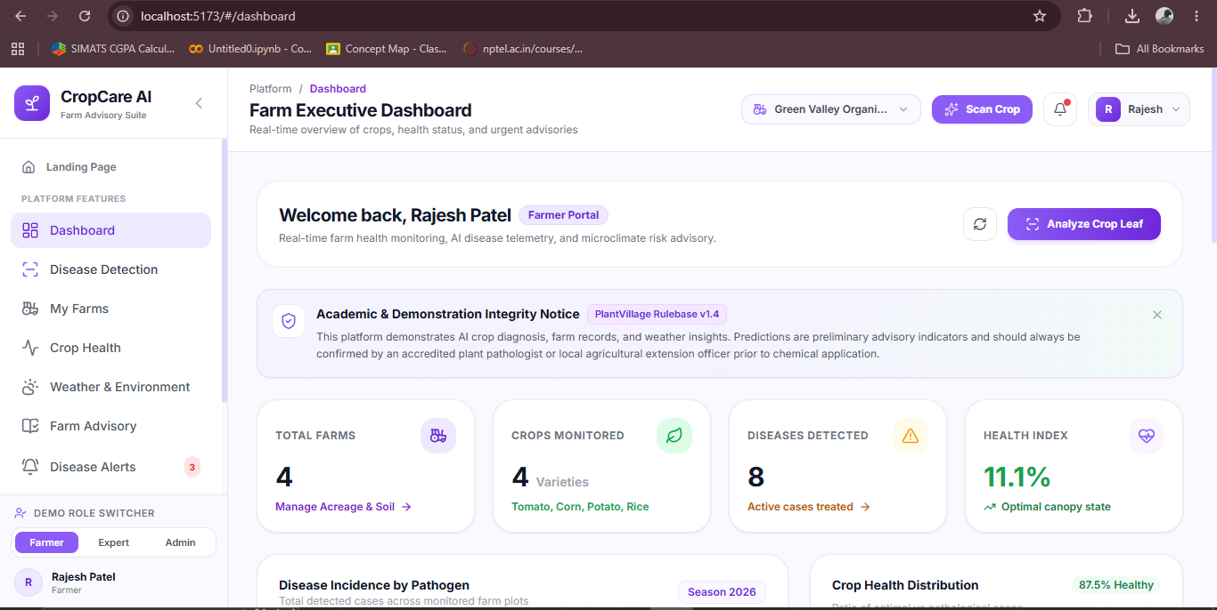
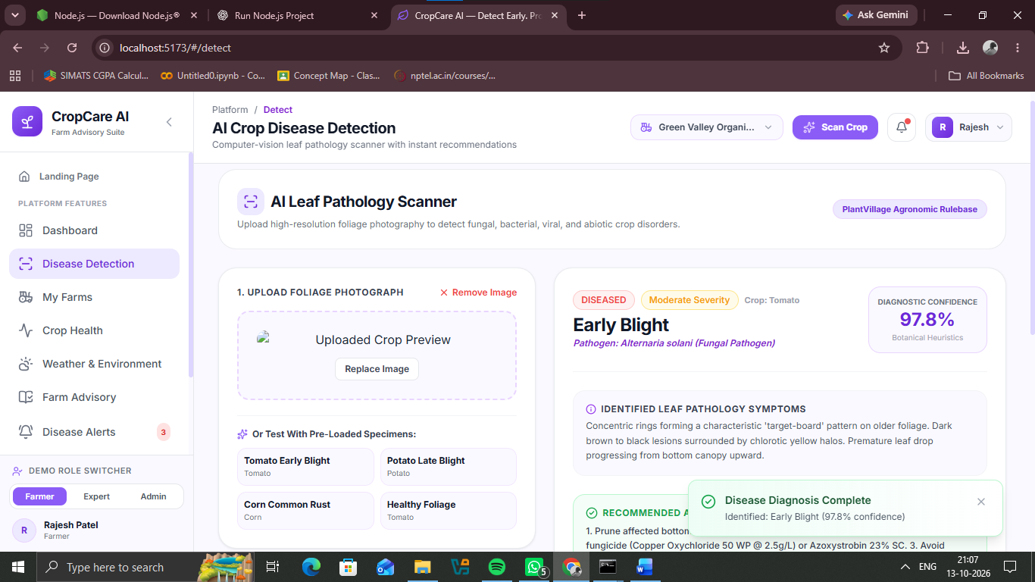
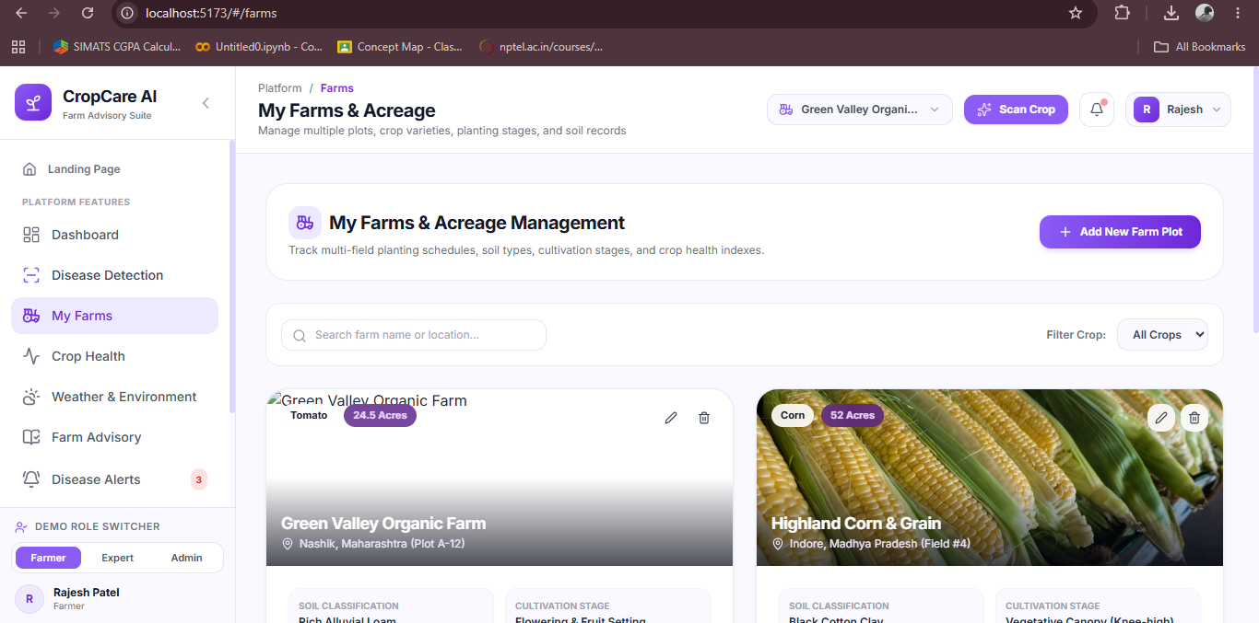
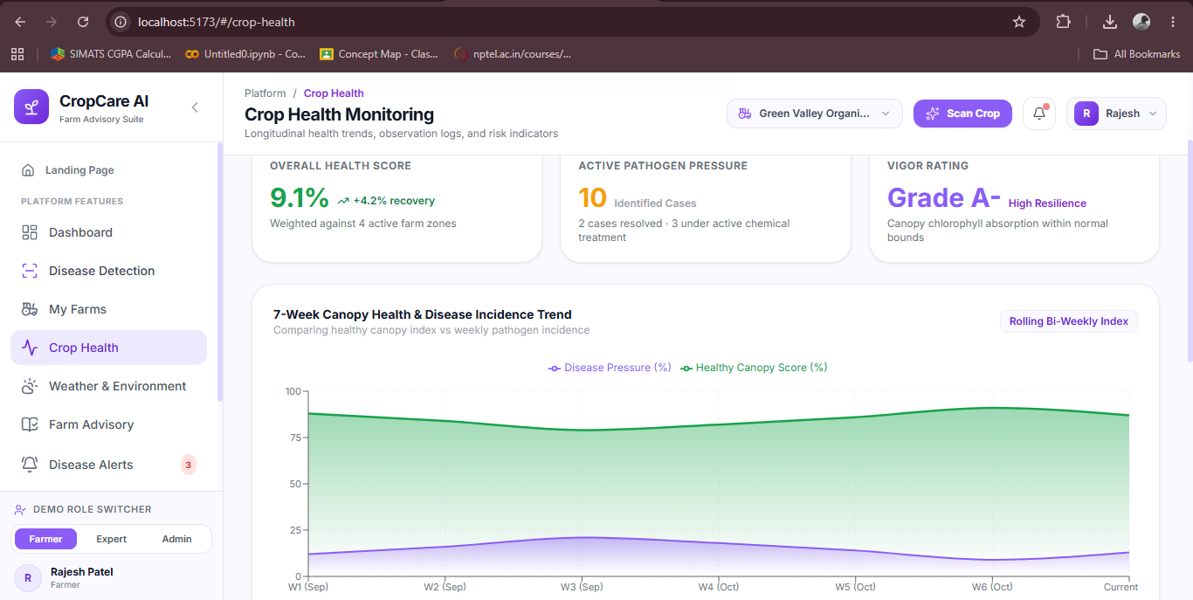
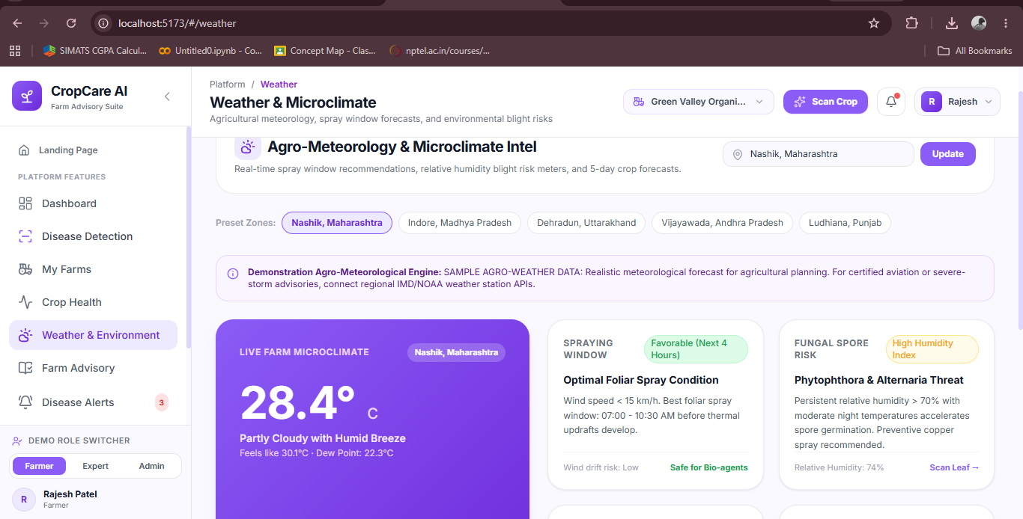
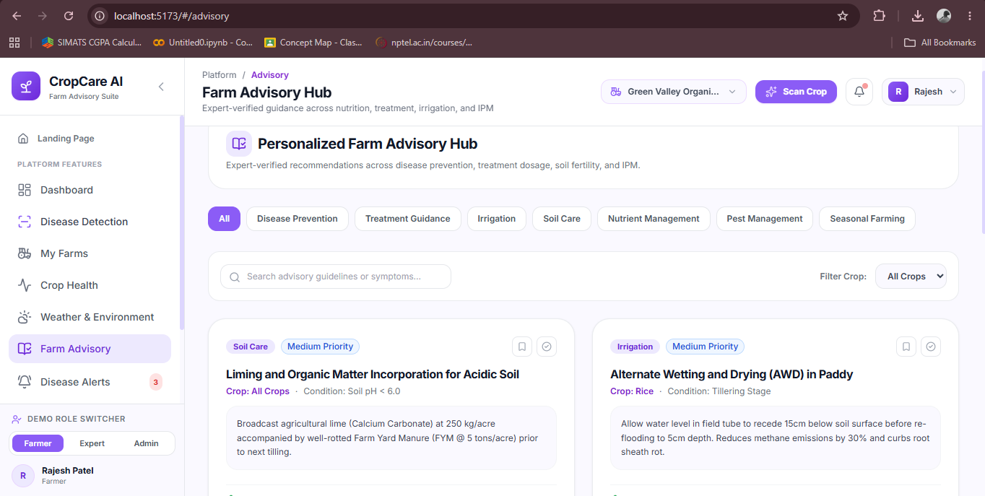
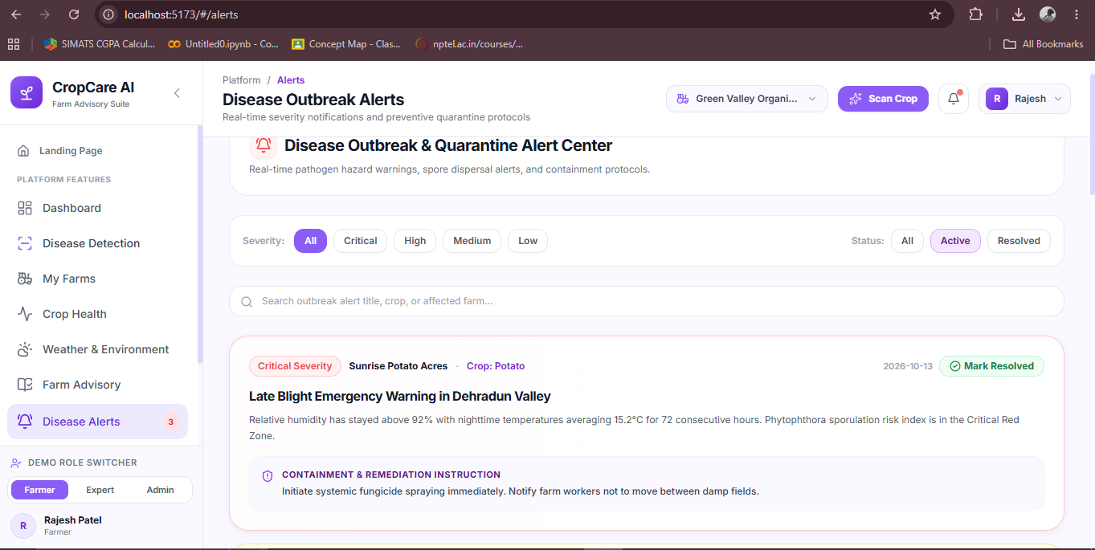

9.0 REFERENCES
The analysis and architectural formulation in this report draw upon verified academic literature, official institutional assessment specifications, and authoritative agricultural guidelines:
1. SIMATS Engineering (Saveetha School of Engineering), 'CSA10 Software Engineering Course Curriculum & CO1 Assessment Tool 1: Case Study Analysis', Department of Computer Science and Engineering, 2026.
2. SIMATS Engineering, 'CSA10 Problem Statements Allocation Document – Problem Statement #7: Crop Disease Detection and Farm Advisory Platform (Agriculture)', 2026.
3. Food and Agriculture Organization (FAO), 'The State of Food and Agriculture: Leveraging Automation in Agriculture for Transforming Agrifood Systems', United Nations, Rome, 2022.
4. Indian Council of Agricultural Research (ICAR), 'Handbook of Agriculture: Facts and Figures for Farmers, Students, and All Interested in Farming', Directorate of Knowledge Management in Agriculture, New Delhi, 2023.
5. Hughes, D. P., & Salathé, M., 'An open access repository of images on plant health to enable the development of mobile disease diagnostics', arXiv preprint arXiv:1511.08060 (PlantVillage Project), 2015.
6. Mohanty, S. P., Hughes, D. P., & Salathé, M., 'Using deep learning for image-based plant disease detection', Frontiers in Plant Science, Vol. 7, Article 1419, pp. 1-10, 2016. DOI: 10.3389/fpls.2016.01419.
7. Pressman, R. S., & Maxim, B. R., 'Software Engineering: A Practitioner's Approach', 9th Edition, McGraw-Hill Higher Education, New York, 2020.
8. Sommerville, I., 'Software Engineering', 10th Edition, Pearson Education, Boston, 2016.
9. Schwaber, K., & Sutherland, J., 'The Scrum Guide: The Definitive Guide to Scrum: The Rules of the Game', Scrum.org, 2020.
10. World Health Organization & FAO, 'International Code of Conduct on Pesticide Management: Guidelines on Good Labelling Practice for Pesticides', Rome, 2015.
11. World Wide Web Consortium (W3C), 'Web Content Accessibility Guidelines (WCAG) 2.1', W3C Recommendation, 2018.

